**README:**

**How to run the code:**

1. You will see three variables namely: yelpFilePath, amazonFilePath and imdbFilePath all containing the paths to their respective files. REPLACE THE PATH WITH YOUR LOCAL PATH.

Also change the path variable in f.open() depending on the dataset you wish to run the code.  
  
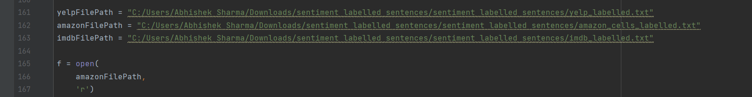

1. In the part where we calculate the probabilities of each word, replace the value of ‘m’ according to the value you want to test on and run the code.  
     
   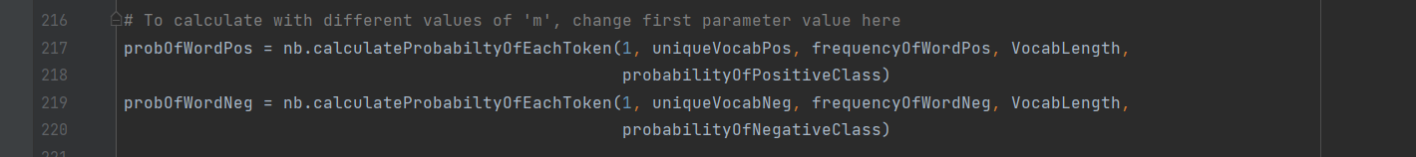
2. The program gives in the output : value of ‘m’ used, list of Predicted Labels, list of Actual Labels and the Accuracy.  
     
   